import numpy as np

from scipy.special import gammaln, psi, polygamma

import sys

from sam.pickle_file_io import PickleFileIO

from sam.math_util import *

import sam.optimize as optimize

import sam.log as log

class VEMModel(PickleFileIO):

def __init__(self, reader=None, T=None):

assert reader is not None

self.T = T if T is not None else 10 # Number of topics

self.iteration = 0 # Number of iterations completed

# Set up a reader to access the corpus. This gives the data dimensionality (D), the number of documents,

# the number of data, the number of document classes, and the document labels (as well as whether a

# document label was observed).

self.reader = reader

self.corpus_file = self.reader.filename

self.V = self.reader.dim # Vocab size

self.D = self.reader.num_docs

self.num_docs = self.reader.num_docs

# For efficiency, read the corpus into memory

self.load_corpus_as_matrix()

# Variational parameters

self.alpha = np.ones(self.T) * 1.0 + 1.0

self.m = l2_normalize(np.ones(self.V)) # Parameter to p(mu)

self.kappa0 = 10.0

self.kappa1 = 5000.0

self.xi = 5000.0

self.vm = l2_normalize(np.random.rand(self.V))

self.vmu = l2_normalize(np.random.rand(self.V, self.T))

# Initialize vAlpha

self.valpha = np.empty((self.T, self.num_docs))

for d in range(self.num_docs):

distances_from_topics = np.abs(cosine_similarity(self.v[:, d], self.vmu)) + 0.01

self.valpha[:, d] = distances_from_topics / sum(distances_from_topics) * 3.0

def __setstate__(self, state):

self.__dict__.update(state)

# Reset corpus_file just in case the reader loads the corpus from a different directory

self.corpus_file = self.reader.filename

self.load_corpus_as_matrix()

def __getstate__(self):

state = self.__dict__.copy()

del state['v']

return state

def load_corpus_as_matrix(self):

self.v = np.empty((self.V, self.num_docs))

for d in xrange(self.num_docs):

self.v[:, d] = self.reader.read_doc(d).T

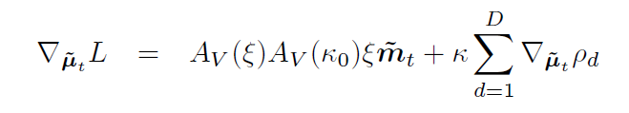

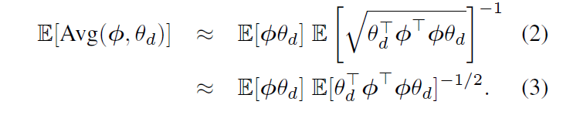

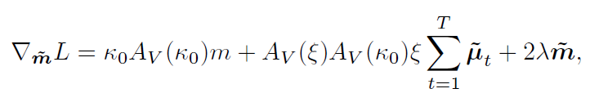

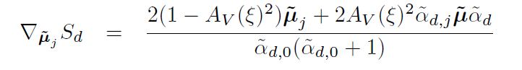

def l_valpha(self):

alpha0 = np.sum(self.alpha)

psi_valpha = psi(self.valpha)

valpha0s = self.valpha.sum(axis=0)

psi_valpha0s = psi(valpha0s)

sum_of_rhos = np.sum(self.rho_batch())

# (alpha_minus_one_matrix * psi_valpha).sum() \

like = np.dot(asrowvector(self.alpha - 1.0), psi_valpha).sum() \

- (alpha0 - self.T)*psi_valpha0s.sum() \

+ self.D*gammaln(alpha0) \

- self.D*gammaln(self.alpha).sum() \

+ self.kappa1 * sum_of_rhos \

- np.sum((self.valpha - 1.0) * psi_valpha) \

+ np.sum(psi_valpha0s * (valpha0s - self.T)) \

- np.sum(gammaln(valpha0s)) \

+ np.sum(gammaln(self.valpha))

return like

def l_alpha(self):

alpha0 = np.sum(self.alpha)

psi_valpha = psi(self.valpha)

psi_valpha0s = psi(np.sum(self.valpha, axis=0))

likelihood = np.sum( ascolvector(self.alpha - 1) * psi_valpha ) \

- (alpha0 - self.T)*np.sum(psi_valpha0s) \

+ self.D*gammaln(alpha0) \

- self.D*np.sum(gammaln(self.alpha))

return likelihood

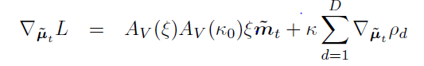

def l_vmu(self):

a_xi = avk(self.V, self.xi)

a_k0 = avk(self.V, self.kappa0)

sum_of_rhos = sum(self.rho_batch())

? vm_dot_sum_of_vmu = np.dot(self.vm.T, np.sum(self.vmu, axis=1))

likelihood = a_xi*a_k0*self.xi*vm_dot_sum_of_vmu + self.kappa1*sum_of_rhos

return likelihood

def l_xi(self):

a_xi = avk(self.V, self.xi)

a_k0 = avk(self.V, self.kappa0)

sum_of_rhos = sum(self.rho_batch())

return a_xi*self.xi * (a_k0*np.dot(self.vm.T, np.sum(self.vmu, axis=1)) - self.T) \

+ self.kappa1*sum_of_rhos

def grad_l_valpha(self):

alpha0 = np.sum(self.alpha)

valpha0s = np.sum(self.valpha, axis=0)

grad_psi_valpha = polygamma(1, self.valpha)

grad_psi_valpha0s = polygamma(1, valpha0s)

grads_of_rho = self.grad_rho_valpha_batch()

grad = ascolvector(self.alpha - 1.0) * grad_psi_valpha \

+ self.kappa1*grads_of_rho \

- (self.valpha - 1)*grad_psi_valpha

addToEachRow = -grad_psi_valpha0s*(alpha0 - self.T) \

+ grad_psi_valpha0s*(valpha0s - self.T)

grad += asrowvector(addToEachRow)

return grad

def grad_l_vmu(self):

#avk = mean resultant length VMF

a_xi = avk(self.V, self.xi)

a_xi_squared = a_xi**2

a_k0 = avk(self.V, self.kappa0)

esns = self.e_squared_norm_batch()

valpha0s = np.sum(self.valpha, axis=0)

# For single d: aXi/vAlphaD0 /sqrt(esn) * vd * vAlphaD'

first_term = np.dot(self.v, (self.valpha * a_xi / asrowvector(valpha0s * np.sqrt(esns))).T)

# Weights per document for everything that was in GradESN; from second term in GradRhoVMu_BatchT

# For a single d: aXi/vAlphaD0 / (2*esn^(3/2)) * dot(model.vMu*vAlphaD, vd)

per_doc_weights = a_xi / valpha0s / (2*esns ** (3./2.)) \

* (self.valpha * np.dot(self.vmu.T, self.v)).sum(axis=0).T

second_term_doc_weights = 2*(1-a_xi_squared) / (valpha0s*(valpha0s+1)) # Same dim as valpha0s

second_term = np.sum(per_doc_weights * second_term_doc_weights) * self.vmu

# Last term in GradESN times per-doc factors from GradRhoVMu...

third_term_doc_weights = per_doc_weights * 2*a_xi_squared / (valpha0s*(valpha0s+1)) # From GradESN

# Instead of

#rescaled_valphas = self.valpha * asrowvector(np.sqrt(third_term_doc_weights))

#third_term = np.dot(self.vmu, np.dot(rescaled_valphas, rescaled_valphas.T))

third_term = np.dot(self.vmu, np.dot(self.valpha * asrowvector(third_term_doc_weights), self.valpha.T))

sum_over_documents = first_term - second_term - third_term

return ascolvector(a_xi*a_k0*self.xi*self.vm) + self.kappa1*sum_over_documents

def grad_l_alpha(self):

alpha0 = np.sum(self.alpha)

valpha0s = np.sum(self.valpha, axis=0)

return np.sum(psi(self.valpha), axis=1) - np.sum(psi(valpha0s)) \

+ self.D*psi(alpha0) - self.D*psi(self.alpha)

**Derivative of this equation WRT ξ?**

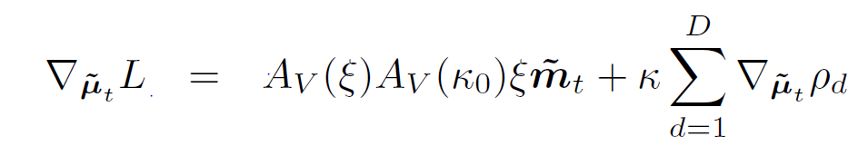

def grad_l_xi(self):

a_xi = avk(self.V, self.xi)

a_prime_xi = deriv_avk(self.V, self.xi)

a_k0 = avk(self.V, self.kappa0)

sum_over_documents = sum(self.deriv_rho_xi())

# (a_k0*np.dot(self.vm.T, np.sum(self.vmu, axis=1)) - self.T)

return (a_prime_xi*self.xi + a_xi) * (a_k0*np.dot(self.vm.T, np.sum(self.vmu, axis=1)) - self.T) \

+ self.kappa1*sum_over_documents

def tangent_grad_l_vmu(self):

"""

The gradient of the likelihood bound with respect to vMu, projected into the tangent space of the hypersphere.

"""

grad = self.grad_l_vmu()

# Project the gradients into the tangent space at each topic

for t in range(self.T):

vmu_t = self.vmu[:, t]

grad[:, t] = grad[:, t] - np.dot(vmu_t, np.dot(vmu_t.T, grad[:, t]))

return grad

def rho_batch(self):

esns = self.e_squared_norm_batch()

valpha0s = self.valpha.sum(axis=0)

# vmu: V by T

# v: V by D

# vmu' * v: T by D

vmu_times_v = self.vmu.T.dot(self.v)

return np.sum(self.valpha * asrowvector(1.0/valpha0s/np.sqrt(esns)) * vmu_times_v, axis=0) \

* avk(self.V, self.xi)

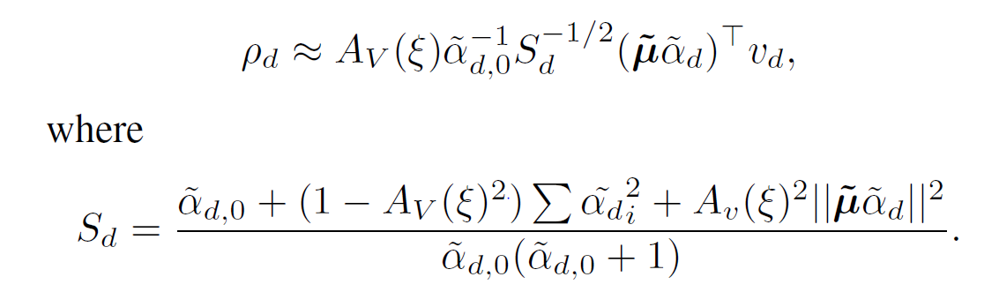

def grad_rho_valpha_batch(self):

valpha0s = np.sum(self.valpha, axis=0)

a_xi = avk(self.V, self.xi)

derivsOfESquaredNorm = self.grad_e_squared_norm_batch()

esns = self.e_squared_norm_batch()

vMuDotVd = np.dot(self.vmu.T, self.v) # T by D

vMuTimesVAlphaDotVd = np.sum(self.valpha * vMuDotVd, axis=0)

grad = vMuDotVd / asrowvector(valpha0s)

# Subtract a constant from each column

grad -= asrowvector(vMuTimesVAlphaDotVd / (valpha0s**2))

# Divide each column by sqrt(esns(d))

grad /= asrowvector(np.sqrt(esns))

s = vMuTimesVAlphaDotVd / valpha0s / (2*esns**(3./2.))

grad = a_xi * (grad - derivsOfESquaredNorm * asrowvector(s))

return grad

def e_squared_norm_batch(self):

valpha0s = self.valpha.sum(axis=0)

valpha_squares = np.sum(self.valpha**2, axis=0)

a_xi_squared = avk(self.V, self.xi) ** 2

vMuDotVMu = np.dot(self.vmu.T, self.vmu) # T by T

vMuVAlphaVMuVAlpha = np.sum(

np.dot(self.valpha.T, vMuDotVMu).T * self.valpha,

axis=0)

esns = (valpha0s + (1.0-a_xi_squared)*valpha_squares + a_xi_squared*vMuVAlphaVMuVAlpha) / (valpha0s * (valpha0s + 1))

return esns

def grad_e_squared_norm_batch(self):

valpha0s = np.sum(self.valpha, axis=0)

a_xi_squared = avk(self.V, self.xi) ** 2

esns = self.e_squared_norm_batch()

vMuTimesVAlphaTimesVMu = np.dot(self.valpha.T, np.dot(self.vmu.T, self.vmu)) # D by T

per_doc_weights = 1./(valpha0s * (valpha0s + 1))

grad = (1 + 2*(1-a_xi_squared)*self.valpha + 2*a_xi_squared*vMuTimesVAlphaTimesVMu.T)

grad -= esns * asrowvector(2*valpha0s + 1)

grad *= asrowvector(per_doc_weights)

return grad

def deriv_rho_xi(self):

""" Gradient of each Rho_d with respect to xi. """

a_xi = avk(self.V, self.xi)

deriv_a_xi = deriv_avk(self.V, self.xi)

valpha0s = np.sum(self.valpha, axis=0)

esns = self.e_squared_norm_batch()

deriv_e_squared_norm_xis = self.grad_e_squared_norm_xi()

vMuTimesVAlphaDotDoc = np.sum(self.valpha * np.dot(self.vmu.T, self.v), axis=0)

deriv = deriv_a_xi * vMuTimesVAlphaDotDoc / (valpha0s * np.sqrt(esns)) \

- a_xi/2 * vMuTimesVAlphaDotDoc / (valpha0s * esns**1.5) * deriv_e_squared_norm_xis

return deriv

def grad_e_squared_norm_xi(self):

""" Gradient of the expectation of the squared norms with respect to xi """

a_xi = avk(self.V, self.xi)

deriv_a_xi = deriv_avk(self.V, self.xi)

valpha0s = np.sum(self.valpha, axis=0)

sum_valphas_squared = np.sum(self.valpha**2, axis=0)

vMuVAlphaVMuVAlpha = np.sum(np.dot(self.valpha.T, np.dot(self.vmu.T, self.vmu)).T * self.valpha, axis=0)

deriv = 2*a_xi*deriv_a_xi*(vMuVAlphaVMuVAlpha - sum_valphas_squared) / (valpha0s * (valpha0s + 1))

return deriv



def update_vm(self):

self.vm = l2_normalize(

self.kappa0*self.m + avk(self.V, self.xi)*self.xi*np.sum(self.vmu, axis=1)

)

Calculate average topic

def update_m(self):

self.m = l2_normalize(np.sum(self.vmu, axis=1)) # Sum across topics

def update_valpha(self):

optimize.optimize_parameter(self, 'valpha', self.l_valpha, self.grad_l_valpha)

def update_alpha(self):

optimize.optimize_parameter(self, 'alpha', self.l_alpha, self.grad_l_alpha)

def update_xi(self):

optimize.optimize_parameter(self, 'xi', self.l_xi, self.grad_l_xi)

def update_vmu(self):

# XXX: The topics (vmus) must lie on the hypersphere, i.e. have unit L2 norm. I'm not sure if scipy has

# an optimization method that can accommodate this type of constraint, so instead, I'm encoding

# it here a Lagrange multiplier. This should at least push the optimizer towards solutions close to the

# L2 constraint.

# Set the strength of the Lagrange multipler to something much larger than the objective

LAMBDA = 10.0*self.l_vmu()

def f():

squared_norms = np.sum(self.vmu ** 2, axis=0)

return self.l_vmu() - LAMBDA*np.sum((squared_norms - 1.0)**2)

def g():

squared_norms = np.sum(self.vmu ** 2, axis=0)

return self.tangent_grad_l_vmu() - LAMBDA*2.0*(squared_norms - 1.0)*(2.0*self.vmu)

optimize.optimize_parameter(self, 'vmu', f, g, bounds=(-1.0, 1.0))

self.vmu = l2_normalize(self.vmu) # Renormalize

def run_one_iteration(self):

# theta - vector of topic proportions for a particular document

# phi - topics -- size vocab-1; we have k topics

# E - expectation step - how likely is each point to fit this distribution

# variational alpha - parameter vector for Dirichlet document-level topics distribution

# of topics x # of documents

log.debug('Updating vAlpha')

self.update_valpha()

# variational mu - global topic distribution parameter - variational topic means

log.debug('Updating vMu')

self.update_vmu()

# variational M - global topic distribution parameter - variational topic means

log.debug('Updating vM')

self.update_vm()

# M - maximization step - fix the distributions to better match expectations

log.debug('Updating M')

self.update_m()

# xi - global topic distribution parameter - variational topic means

log.debug('Updating xi')

self.update_xi()

# vector dimension = topics

log.debug('Updating alpha')

self.update_alpha()

self.iteration += 1

def write_topics(self, f=None, num_top_words=10, num_bottom_words=10):

if f is None:

f = sys.stdout

wordlist = open(self.corpus_file + '.wordlist').readlines() # TODO: not hardcode this?

wordlist = np.array([each.strip() for each in wordlist], str)

for t in range(self.T):

print >>f, 'Topic %d' % t

print >>f, '--------'

sorted_indices = np.argsort(self.vmu[:, t])

sorted_weights = self.vmu[sorted_indices, t]

sorted_words = wordlist[sorted_indices]

print >>f, 'Top weighted words:'

for word, weight in zip(sorted_words[:-num_top_words:-1], sorted_weights[:-num_top_words:-1]):

print >>f, ' %.4f %s' % (weight, word)

print >>f

print >>f, 'Bottom weighted words:'

for word, weight in zip(sorted_words[:num_bottom_words], sorted_weights[:num_bottom_words]):

print >>f, ' %.4f %s' % (weight, word)

print >>f

print >>f

if f is not sys.stdout:

f.close()

def write_topic_weights_arff(self, f=None):

if f is None:

f = sys.stdout

mean_topic_weights = self.valpha / asrxowvector(np.sum(self.valpha, axis=0))

print >>f, '@RELATION topicWeights'

for t in range(self.T):

print >>f, '@ATTRIBUTE topic%d NUMERIC' % t

print >>f, '@ATTRIBUTE class {%s}' % ','.join(self.reader.class_names)

print >>f, '@DATA'

for d in range(self.num_docs):

weights_string = ', '.join([str(each) for each in mean_topic_weights[:, d]])

label = self.reader.raw_labels[d]

print >>f, '%s, %s' % (weights_string, label)

if f is not sys.stdout:

f.close()